HACETTEPE UNIVERSITY DEPARTMENT OF

COMPUTER ENGINEERING

BBM 453 LAB EXPERIMENT



Mehmet Taha USTA – 21527472

Çağlar USLU – 21808388

Mehmet Taha USTA Source = 192.168.1.39

Çağlar USLU Source = 192.168.0.10

**1.** **Is your browser running HTTP version 1.0 or 1.1? What version of HTTP is the server running?**

My browser is running http version 1.1

The server is also running http version 1.1

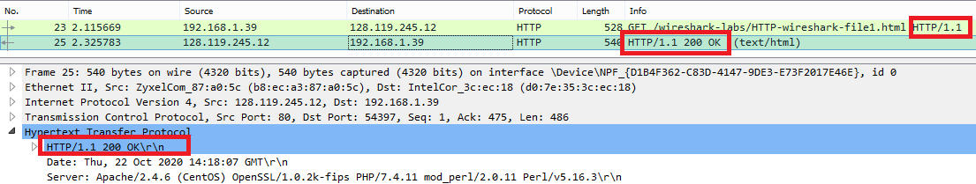

**2.** **What languages (if any) does your browser indicate that it can accept to the server?**

Our browser will accept Turkish language from server

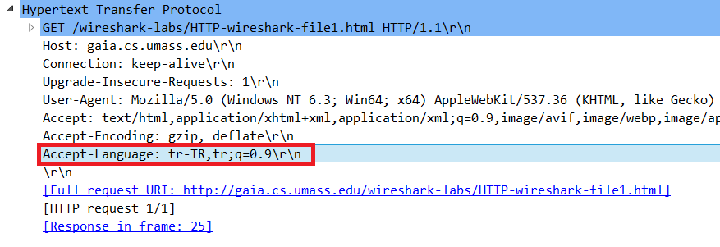

**3.** **What is the IP address of your computer? Of the gaia.cs.umass.edu server?**

The IP address of my computer is 192.168.1.39

The IP address of the server is 128.119.245.12



**4.** **What is the status code returned from the server to your browser?**

The status code returned was 200 OK





**5.** **When was the HTML file that you are retrieving last modified at the server?**

The file was last modified on Thursday, October 22, 2020 at 05:59:03 GMT

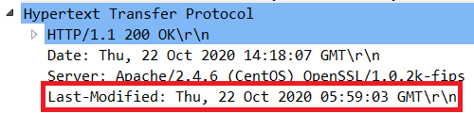

**6.** **How many bytes of content are being returned to your browser?**

128 bytes of content are being returned

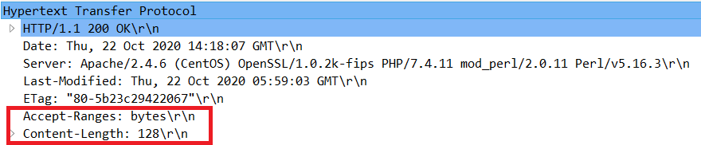

**7.** **By inspecting the raw data in the packet content window, do you see any headers within the data that are not displayed in the packet-listing window? If so, name one.**

I do not see any different headings between the two windows

**8.** **Inspect the contents of the first HTTP GET request from your browser to the server. Do you see an “IF-MODIFIED-SINCE” line in the HTTP GET?**

No there is no IF-MODIFIED-SINCE line in the GET message.

**9.** **Inspect the contents of the server response. Did the server explicitly return the contents of the file? How can you tell?**

The server did explicitly return the contents of the file.

Line-Based Text Data shows what the server sent back to my browser which is specifically what the website showed when I brought it up on my browser.

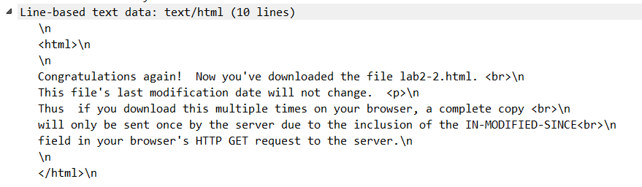

**10.** **Now inspect the contents of the second HTTP GET request from your browser to the server. Do you see an “IF-MODIFIED-SINCE:” line in the HTTP GET? If so, what information follows the “IF-MODIFIED-SINCE:” header?**

Yes in the second HTTP message an IF-MODIFIED-SINCE line is included. The information that follows is the date and time that I last accessed the webpage

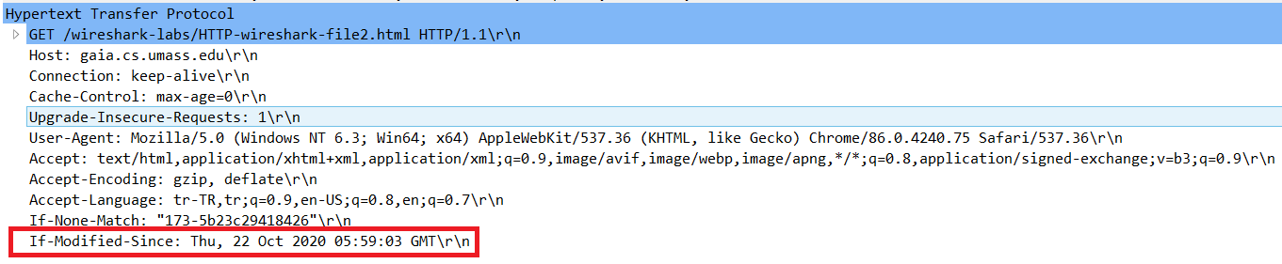

**11.** **What is the HTTP status code and phrase returned from the server in response to this second HTTP GET? Did the server explicitly return the contents of the file? Explain.**

The HTTP status code is “304: Not Modified”

The server did not return the contents of the file because the browser simply retrieved the contents from its cache. Had the file been modified since it was last accessed, it would have returned the contents of the file, instead it simply told my browser to retrieve the old file from its cached memory.

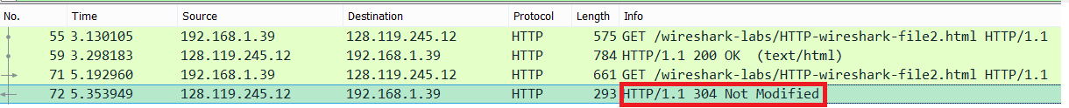

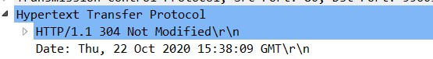

**12.** **How many HTTP GET request messages did your browser send? Which packet number in the trace contains the GET message for the Bill or Rights?**

My browser only sent 1 HTTP GET request to the server.

The Packet that contained the GET message was packet number 160.



**13.** **Which packet number in the trace contains the status code and phrase associated with the response to the HTTP GET request?**

The packet that contains the status code and phrase which the server sent in response to the GET message was packet number 176.



**14.** **What is the status code and phrase in the response?**

The code and phrase in the response was 200 OK



**15.** **How many data-containing TCP segments were needed to carry the single HTTP response and the text of the Bill of Rights?**

The data was sent in 4 TCP segments to the browser. Then reassembled.

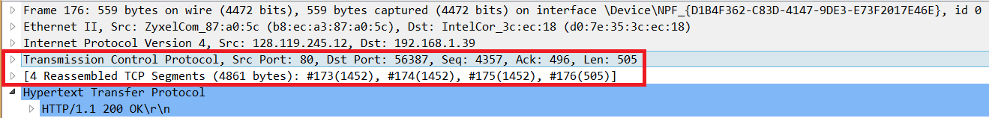

**16.** **How many HTTP GET request messages did your browser send? To which Internet addresses were these GET requests sent?**

My browser sent 3 HTTP GET message requests.

GET requests = The initial page, the Pearson logo, and the cover of the Pearson book

Initial Page address: 128.119.245.12

Pearson Logo: 128.119.245.12

Pearson book, 5th Edition: 128.119.245.12

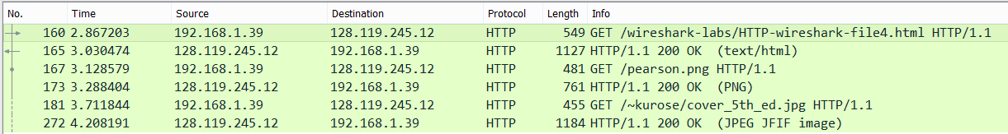

**17.** **Can you tell whether your browser downloaded the two images serially, or whether they were downloaded from the two web sites in parallel? Explain.**

The browser downloaded the two images in serially.

the first image was requested by the browser.

After the first picture request, the desired picture was sent by the server.

After the first picture was sent by the server, the second picture was requested by the browser.



**18.** **What is the server’s response (status code and phrase) in response to the initial HTTP GET message from your browser?**

The servers intial response was “401 Unauthorized”

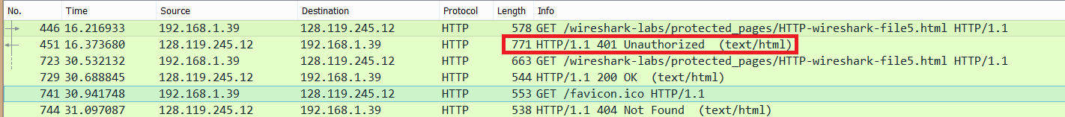

**19.** **When your browser’s sends the HTTP GET message for the second time, what new field is included in the HTTP GET message?**

The new field that is now included is the authorization field.

This is included because we sent the server a username and password along with our request stating that we were authorized to receive the page.

